**The University of Jordan**

|  |
| --- |
| **School of Engineering**  **Department of Computer Engineering** |

|  |
| --- |
| **An Intelligent Skin Disease Diagnosis Application** |

|  |  |  |  |
| --- | --- | --- | --- |
|  |  |  | *Supervisor:* |
|  |  |  | Prof. Iyad Jafar |
| *Author(s):* |  |  |  |
| Hadeel Adas. | | 0197144 |  |
| Fatima Al Zahra’a Ghazal. | | 0194433 |  |

**May 26th, 2024**

|  |
| --- |
| Submitted in partial fulfillment of the requirements of B.Sc. Degree in Computer Engineering |

**This page is intentionally left blank**

# **ETHICAL STATEMENT**

We, the undersigned students, certify and confirm that the work submitted in this project report is entirely our own and has not been copied from any other source. Any material that has been used from other sources has been properly cited and acknowledged in the report.

We are fully aware that any copying or improper citation of references / sources used in this report will be considered plagiarism, which is a clear violation of the Code of Ethics of the University of Jordan.

We further certify and confirm that we had no external help without the approval of our supervisor and proper acknowledgment when it is due. We certify and affirm that we never at any point commissioned a 3rd. party to do the work or any part of it on our behalf regardless of the amount charged or lack thereof. We also acknowledge that if suspected and thereafter proven that we commissioned a 3rd. party to do any part of this project that we risk failing the entire project.

We certify and confirm that all results presented in this project are true with no manipulation of data or fraud, that any statistics done, or surveys collected are conducted with the highest degree of scientific fidelity and integrity, and that if proven otherwise, we risk failing the entire project. We acknowledge that for any data collected, we have taken all the steps necessary in applying for proper authorizations if deemed necessary, and that all user data collected is subject to the utmost degrees of privacy and anonymity.

|  |  |
| --- | --- |
| Hadeel Ali Mohammad Adas. | Fatima Hisham Al Zahra’a Ghazal. |
| May 26th, 2024 | May, 26th, 2024 |
| Signature: | Signature: |

**This page is intentionally left blank**

# **SUPERVISOR CERTIFICATION**

|  |  |
| --- | --- |
| I hereby certify that the students in this project have **successfully finished** their senior year project and by submitting this report they have fulfilled in partial the requirements of B.Sc. Degree in Computer Engineering. |  |
| I hereby certify that the students in this project have not completed their senior year graduation project and **I do not approve** that they proceed to the discussion. |  |
| I suspect that the students have **violated** one or more of the clauses in the **ethical statement** and I suggest that an investigation committee look into the matter. |  |

|  |
| --- |
| Prof. Iyad Jafar |
|  |
| Signature: |

**This page is intentionally left blank**

# **DEDICATION**

We would like to express our deepest gratitude to Allah, who has blessed us with the knowledge and strength to complete this project. Our heartfelt thanks go to our beloved parents and family, whose unwavering support and encouragement have been our foundation throughout this journey. We also extend our sincere appreciation to our friends, who have shared the road with us, and to our classmates for their camaraderie and inspiration.

A special acknowledgment and deep thanks to our supervisor, Dr. Iyad Jafar, whose expertise, encouragement, and continuous guidance have been instrumental in shaping and refining this project. We are grateful for the opportunity to benefit from your wisdom and mentorship. In addition, a special thanks to our esteemed professors and the Computer Engineering department for their invaluable guidance and support. We are hopeful that our education and experiences will enable us to contribute positively to our community and make a meaningful impact on the world.

# **SYMBOLS, ABBREVIATIONS, AND ACRONYMS**

|  |  |
| --- | --- |
| AI | Artificial Intelligence |
| API | Application Programming Interface |
| ASGI | Asynchronous Server Gateway Interface |
| CDSS | Clinical Decision Support System |
| CNN | Convolutional Neural Network |
| CPU | Central Processing Unit |
| ID | Identification |
| iOS | iPhone Operating System |
| RAM | Random Access Memory |
| ResNet | Residual Network |
| UI | User Interface |
| WHO | World Health Organization |
|  |  |
|  |  |
|  |  |
|  |  |
|  |  |
|  |  |
|  |  |
|  |  |
|  |  |
|  |  |

# **ABSTRACT**

Our project aims to enhance accessibility, efficiency, and inclusivity in dermatological care on a global scale. Our project offers a mobile application supported by artificial intelligence to modernize dermatological care. The application provides patients with a smooth journey from login to diagnosis, allowing them to securely input personal information and upload images of their skin conditions for analysis by artificial intelligence. Swift data processing provides diagnostic results in a timely manner, enhancing access to medical information. Additionally, the platform enables effective patient engagement by allowing them to review information, find nearby clinics, and request medical consultations. For healthcare providers, the application provides a platform to share expertise, diagnose patients remotely, and verify images for voluntary contribution. Moreover, patients can contribute to improving the application's accuracy by submitting their own skin images which can be used to expand the dataset on which the AI model is trained.

**Table of Contents**

**ETHICAL STATEMENT** III

**SUPERVISOR CERTIFICATION** V

**DEDICATION** VII

**SYMBOLS, ABBREVIATIONS, AND ACRONYMS** VIII

**ABSTRACT** IX

**LIST OF FIGURES** XII

**LIST OF TABLES** XIII

**CHAPTER 1 INTRODUCTION** 1

**1.1.** **Problem Definition** 1

**1.2.** **Proposed Solution** 2

**1.3.** **Project Deliverables** 2

**1.4.** **Project Impact** 2

• **Economic Impact** 2

• **Societal Impact** 2

• **Public Health Impact** 3

**1.5 Report Organization** 3

**CHAPTER 2 RELATED WORK** 5

**2.1. DermEngine** 5

**2.2. VisualDX** 5

**2.3. Model Dermatol - Wiki** 6

**2.4. First Derm** 6

**CHAPTER 3 SOLUTION DESCRIPTION AND IMPLEMENTATION** 8

**3.4.1 Turning Machine Learning Model into API** 11

**3.4.2 Deploying the API on Server** 12

**3.5. Mobile Application** 12

**3.5.1 User Interface** 12

**3.5.2 Login Process** 13

**3.5.3 Patient Process** 13

**3.5.4 Dermatologist Process** 14

**3.5.5 Volunteering Data in the Mobile Application** 14

**3.5.6 Firebase Database Structure** 15

**CHAPTER 4 RESULTS AND DISCUSSION** 21

**4.1. Machine Learning Model Result** 21

**4.2. Mobile Application Result** 23

**4.2.1 User Authentication and Security** 23

**4.2.2 Patient Diagnosis Process** 23

**4.2.3 Dermatologist Interface** 26

**4.2.4 Volunteer Data Contribution** 27

**CHAPTER 5 CONCLUSIONS AND FUTURE WORK** 28

**5.1** **Conclusions** 28

**5.2** **Future Work** 28

# **LIST OF FIGURES**

Figure 1 - Visualdx application 5

Figure 2 - First derm application 3

Figure 3 - Project Overview 7

Figure 4 - Distribution of diseases before augmentation 9

Figure 5 - Distribution of diseases after augmentation 9

Figure 6 - Firebase Structure 17

Figure 7 - Mobile Application Flowchart 18

Figure 8 - Accuracy for testing the model on the test dataset 20

Figure 9 - Sign up process 21

Figure 10 - Capture Image process. 22

Figure 11 - Patient Options 22

Figure 12 - Data Accessibility by patient 23

Figure 13 - Dermatologist Diagnosis process 23

Figure 14 - Data Accessibility by Dermatologist 24

Figure 15 – Gannt Chart 31

# **LIST OF TABLES**

Table 1 - Compare data set containing images of skin diseases 8

TABLE 2 - Comparison of Model Accuracy on Datasets 20

**This page is intentionally left blank.**

# **CHAPTER 1 INTRODUCTION**

In the field of medical science, the skin, as the largest organ in the human body, plays a vital role that extends beyond mere protection to include complex interactions with the environment. Covering an approximate area of 20 square feet in adults, the skin acts as a primary barrier against external assaults, including pathogens, physical injuries, and environmental stressors. Its essential functions extend to thermoregulation, sensation, and the synthesis of necessary vitamins, emphasizing the skin's fundamental contribution to overall health and well-being. However, continuous exposure and the inherent complexity of the skin make it susceptible to a wide range of conditions, with dermatological diseases potentially compromising an individual's quality of life. Consequently, rapid and accurate recognition and diagnosis of skin diseases emerge as a vital pursuit, despite the challenges faced in the field of dermatology.

Advancements in technology, particularly in the field of artificial intelligence (AI) and mobile applications, present a new opportunity for improvements in early detection and management of skin conditions. This project is positioned at the forefront of these technological advancements, aiming to leverage these innovations through the development of a specialized mobile application for the efficient and effective identification of skin conditions. By integrating advanced AI models capable of analyzing images of skin conditions with precision, this application seeks to provide users with immediate and reliable diagnostic insights. This project not only aims to bridge the gap between initial concern and professional medical consultation but also to enhance accessibility and quality of dermatological care.

Moreover, the application aims to expand beyond mere diagnostic assistance. It seeks to provide users with a comprehensive healthcare experience by facilitating access to nearby dermatology clinics and enabling direct communication with healthcare professionals.

## **Problem Definition**

This project addresses the main challenge of difficulties associated with early detection and management of skin diseases, where the lack of access to specialized care and systemic barriers hinders accurate and timely diagnosis. The proposed mobile application utilizes artificial intelligence to provide quick and reliable preliminary diagnoses, facilitating an initial guide towards specialized care without replacing professional medical examination. It aims to improve access to treatment and promote a proactive approach in dermatological care, emphasizing the need for specialized medical consultation to ensure accuracy and effectiveness in treatment.

## **Proposed Solution**

The proposed solution involves the development of a mobile application equipped with advanced artificial intelligence capabilities to detect the most common skin diseases. This application will offer users a convenient means of capturing images of their skin conditions and receiving AI-driven diagnoses with confidence, along with a report from the World Health Organization (WHO) about the patient's diagnosis. Additionally, patients will have the opportunity to verify their diagnosis with dermatologists, and the application will provide information on the nearest dermatologist clinics to the patient.

## **Project Deliverables**

The final project deliverables include a mobile application will be created. The artificial intelligence model will be integrated to detect skin diseases with proven accuracy and sensitivity. The application includes the following features:

* Image Capture and Analysis: Users can capture images of their skin ailments using the mobile application. These images are then subjected to analysis by AI models trained to identify a most common of skin diseases.
* Confident Diagnosis: Upon analysis, users receive a diagnosis with a confidence level backed by AI algorithms. This diagnosis is presented along with relevant information sourced about the diagnosis from World Health Organization.
* Geolocation-Based Recommendations: The application utilizes geolocation data to suggest nearby dermatologist clinics to users. This feature enhances accessibility to professional medical assistance.
* Doctor's Diagnosis Comparison: Users have the option to submit their images for a doctor's diagnosis to validate the AI diagnosis.
* Voluntary Contribution of Data: Users can volunteer their images along with the doctor's diagnosis to the system. This data contributes to the continuous improvement of the AI models by enriching the dataset with diverse and validated information.
* Emphasis on Medical Consultation: The application emphasizes the importance of consulting a dermatologist for conclusive and precise evaluations. Users are reminded that the application serves as a supportive tool and not a substitute for professional medical diagnosis.

## **Project Impact**

* **Economic Impact**

Timely diagnosis and treatment of skin diseases can lead to cost savings in healthcare systems by preventing the progression of diseases and reducing the need for expensive treatments or hospitalizations. By providing a cost-effective alternative for preliminary diagnosis, the application could alleviate the financial burden on both individuals and healthcare providers.

* **Societal Impact**

The application can have profound societal implications by empowering individuals to take control of their health and well-being. By offering early insights and access to medical information, it promotes health literacy and encourages proactive healthcare behaviors.

* **Public Health Impact**

Early detection of skin diseases not only benefits individual patients but also helps prevent the spread of infectious skin conditions within communities. By providing accurate and timely diagnoses, the application supports public health initiatives aimed at controlling the spread of contagious diseases and reducing the overall incidence of skin-related illnesses.

## **1.5 Report Organization**

This section outlines the structure and content of each chapter and section in our report, ensuring a logical flow and comprehensive coverage of our work. Below is a typical organization for a graduation project report.

**Chapter 1 Introduction:**

* Problem Definition: Clearly defines the project's challenge, including background, context, and significance.
* Proposed Solution: Describes the approach or methodology to solve the identified problem.
* Project Deliverables: Lists expected outcomes, products, or results from project completion.
* Project Impact: Explores potential economic, societal, and public health implications.
* Work Distribution and Timeline: Details task allocation among team members and key project milestones.
* Report Organization: Provides an overview of the report's structure for reader guidance.

**Chapter 2 Related Work:**

In this section, we provide an overview of existing research relevant to our project's topic, offering insights into the current state of knowledge in the field. By reviewing existing literature, studies, and solutions, we identify gaps or limitations in the current understanding or approaches. Our project aims to address these gaps by introducing innovative methods, technologies, or solutions to advance the field and contribute to existing knowledge**.**

**Chapter 3 Solution Description and Implementation:**

3.1-3.5.6: Provides detailed descriptions of the solution proposed in the project and its implementation. This chapter may include subsections covering aspects such as solution architecture, data collection and preprocessing, development of machine learning models, API development, mobile application design, and database structure.

**Chapter 4 Result and Discussion:**

4.1 Machine Learning Model Result: Presents the results obtained from the machine learning model.

4.2 Mobile Application Result:

* 4.2.1 User Authentication and Security: Discusses the effectiveness of the user authentication process.
* 4.2.2 Patient Diagnosis Process: Analyzes the usability and functionality of the patient interface.
* 4.2.3 Dermatologist Interface: Analyzes the usability and functionality of the dermatologist interface.
* 4.2.4 Volunteer Data Contribution: Evaluates the impact of volunteer data on the project.

**Chapter 5 Conclusions and Future Work:**

5.1-5.2: Summarizes the conclusions drawn from the project, emphasizing key findings and insights. It also outlines potential areas for future research, development, or improvement based on the project's outcomes.

# **CHAPTER 2 RELATED WORK**

This chapter provides a brief review of the work and similar applications that has been done similar to our project idea and we list the advantages and disadvantages related to each one of them.

## **2.1. DermEngine**

Intelligent dermatology software for the imaging, documentation, and analysis of skin conditions including skin cancer. This smart dermatology system helps dermatologist to manage their busy workflows with secure cross-platform access [1].

The process has main four steps:

• Users capture images of spot.

• Images are securely sent to medical experts using DermEngine.

• Medical experts review the images.

• Comprehensive report sent to the user.

The main advantages of DermEngine are designed to simplify, allows dermatologists to focus on their patients - not the process, the system’s powerful features run award-winning algorithms designed for dermatology, accessible the cross-platform system is available across iOS, and Android, the web, Mac and Apple TV, and it is affordable DermEngine leading image analytics features come at a price, fit for any size clinic or budget.

The DermEngine lacks to automated scheduling, credit card processing, reporting and statistics, treatment planning, and medical billing, and lacks the use of artificial intelligence to help predict diagnosis.

## **2.2. VisualDX**

VisualDx is an award-winning clinical decision support system designed to enhance medical decisions, aid therapeutic decisions, and improve patient safety [2]. VisualDx is clinical decision support system (CDSS) software intended to be used by medical practitioners, including primary care practitioners, to assist them in differential diagnosis. In one of its modes of operation, after a healthcare provider enters some basic facts about the patient, VisualDx presents peer-reviewed photographs or diagrams of medical conditions such as skin conditions, ordered from the most to the least likely, to assist in diagnosis.

The VisualIDX includes the following features:

• World’s best curated medical image library Leading skin of color atlas

• Smart search for chief complaints, conditions, and drug reactions

• Custom patient-specific differential diagnosis builder

• Tools to improve patient engagement and satisfaction

Overall, VisualDx works very well. The interface is easy to use and walks the user through the search process; the image collection is excellent; and the availability of multiple access routes would appeal to a variety of users.

The lack of references, both in provenance on the images and citations on the monographs, is VisualDx's biggest flaw, it is specifically intended for use by medical practitioners, as patients alone cannot benefit from it, and lacks the use of artificial intelligence in helping for predicting diagnosis.

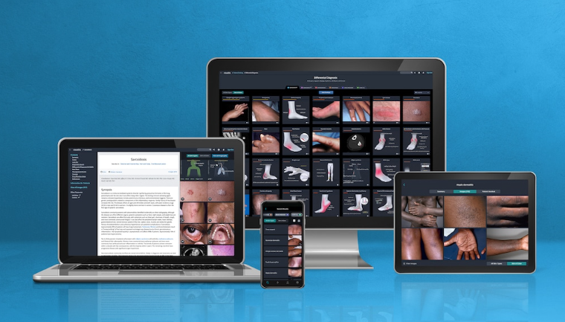

Figure 1 - VisualDx Application.

## **2.3. Model Dermatol - Wiki**

Model Dermatol - Wiki, an app developed by Iderma, utilizes artificial intelligence to analyze photographs of skin conditions and provide instant medical information. It covers a wide range of skin issues, including diseases like warts and shingles, skin cancer like melanoma, and various rashes such as hives. Available to everyone, not just medical professionals, the app allows users to capture and submit images for analysis, supporting 104 languages. While it offers the convenience of identifying 186 skin diseases, its main drawback is the absence of verification by dermatologists. Nevertheless, its accessibility, multilingual support, and comprehensive coverage make it a valuable tool for individuals seeking information about their skin concerns [3].

## **2.4. First Derm**

First Derm is an online dermatology service providing quick, expert, and confidential skin condition evaluations from board-certified dermatologists [4]. First Derm is a US-based online dermatology and telehealth website providing answers to skin conditions. Users send in cases to board-certified dermatologists via an iOS, Android, or Web app.

The process involves submitting two photos: a close-up of your skincare concern (4 inches away) and an image taken from at least 12 inches away. After filling out information related to the symptoms, then paying the case fee (most major credit cards and HSAs accepted), and a practitioner will review the case. Finally getting an answer with potential causes and recommended treatments.

While First Derm doctors do not offer prescriptions, the site notes that 70% of cases require over-the-counter treatments only. It also offers consultations in languages ​​other than English, including German, Spanish and Italian. First Derm is one of the less expensive options and provides an easy-to-follow process [5], but it does not offer suggested clinics; It provides written responses only and no prescriptions are provided.

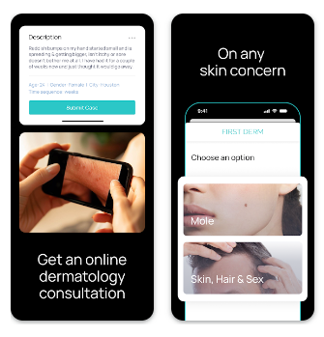

Figure 2 - FirstDerm Application.

# **CHAPTER 3 SOLUTION DESCRIPTION AND IMPLEMENTATION**

**3.1. Project Overview**

The project aims to tackle the significant challenge of early detection and management of skin diseases, particularly in areas with limited access to specialized dermatological care. The proposed solution is a mobile application that leverages advanced artificial intelligence (AI) to provide quick and reliable preliminary diagnoses of common skin conditions. By allowing users to capture and analyze images of their skin ailments, the app offers an AI-driven diagnosis along with informative resources from the World Health Organization (WHO). Additionally, the app helps users find nearby dermatologists based on their location and offers an option to validate the AI diagnosis with a professional dermatologist. Emphasizing the importance of professional medical consultation, the application serves as a supportive tool to enhance accessibility to dermatological care and promote proactive health management. Fig 3- represent the overview of the project.

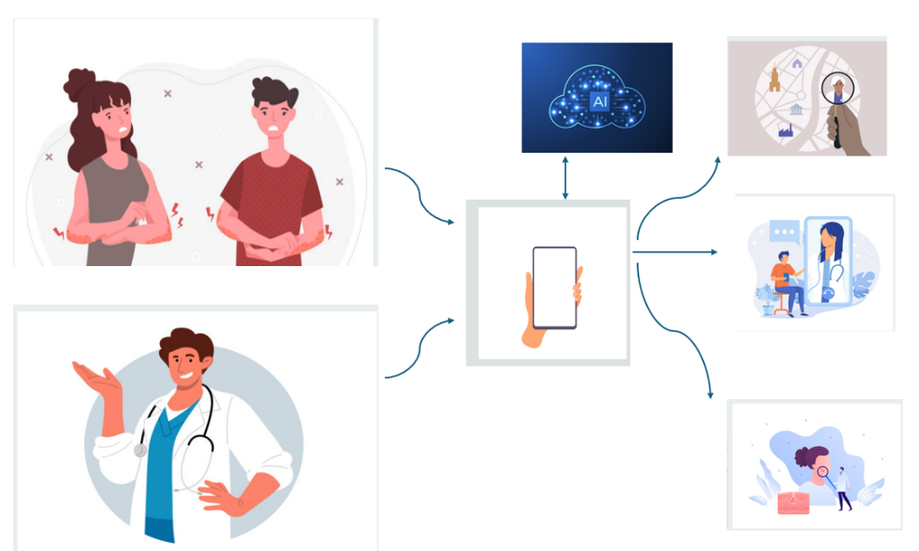

Figure 3 - Project Overview.

**3.2. Data Processing**

Our research journey began with an extensive review of the literature on skin disease classification, aiming to identify the most used datasets, machine learning models, and methodologies. Over the course of my investigation, we meticulously analyzed ten research papers that have made significant contributions to this field [6]-[15].

The primary objective was to understand the landscape of existing research and to draw insights that would inform the development of our project. The reviewed papers encompassed a diverse range of approaches and techniques, each offering unique perspectives on the challenges and advancements in skin disease classification. Initially, we conducted research to identify the most relevant datasets containing images of skin diseases, and we found four datasets: HAM10000, ISIC, Dermnet, and PH2. We then detailed each dataset according to the number of diseases and the number of images within each dataset.

Subsequently, we selected the two best datasets, namely HAM10000 and Dermnet. We chose to incorporate all diseases present in HAM10000 and supplemented them with additional diseases from Dermnet to enrich the dataset and maintain the accuracy of the artificial intelligence model. This decision was made through experimentation to ensure optimal performance of the AI model.

The HAM10000 dataset contains 7 different diseases and approximately 10,000 images, while the Dermnet dataset contains 23 different diseases and approximately 25,000 images. The image set in Dermnet is diverse but may be unbalanced. Therefore, adding more diseases from this dataset could pose a challenge in obtaining a high-accuracy artificial intelligence model.

Table1 represents a comparison between data sets in the field of skin disease analysis in terms of the number of diseases and the number of images.

Table 1- Overview of Skin Diseases Datasets

|  |  |  |
| --- | --- | --- |
| **Dataset** | **Number of diseases** | **Number of images** |
| HAM10000 | 7 | 10000 |
| Dermnet | 23 | 21000 |
| PH2 | 3 | 200 |
| ISIC | 8 | 25300 |

The dataset undergoes a series of transformations to prepare it for training. Initially, the images are resized to dimensions of 224 x 224 pixels to ensure uniformity in input size. Subsequently, a variety of augmentations are applied to diversify the dataset and enhance the model's robustness. These augmentations include random horizontal and vertical flips, random rotation within a certain degree range, and color adjustments such as brightness, contrast, and hue modifications. These transformations introduce variations in the dataset, enabling the model to learn from a wider range of scenarios and improve its generalization ability. Afterward, normalization is applied using the mean and standard deviation of the dataset to make the images ready for input to the model. Furthermore, we performed image augmentation to balance the number of images across all classes.

Figures 4 and 5 illustrate the distribution of diseases in our dataset before and after data augmentation. Figure 4 displays the initial imbalance in disease representation, highlighting the uneven distribution of images across different disease categories. Figure 5 demonstrates the result after applying data augmentation techniques, showcasing a balanced dataset where each disease category has an equal number of images. This balance is crucial for training an effective AI model, as it ensures that no single disease category is underrepresented, thereby improving the model's overall accuracy and reliability.

. 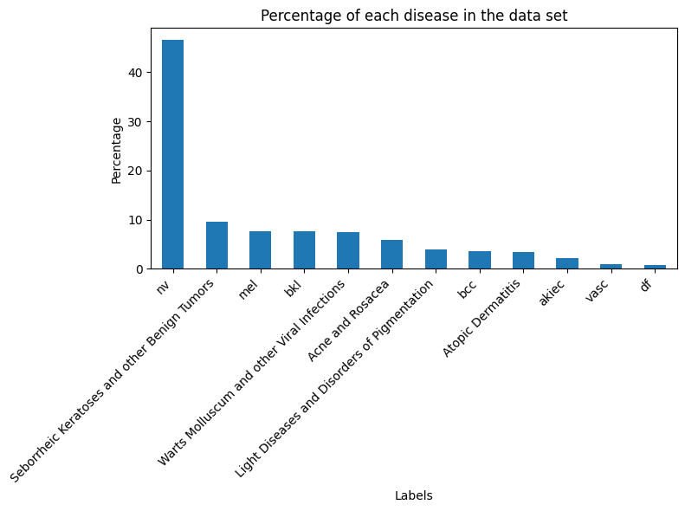

Figure 4-Distribution of diseases before augmentation.

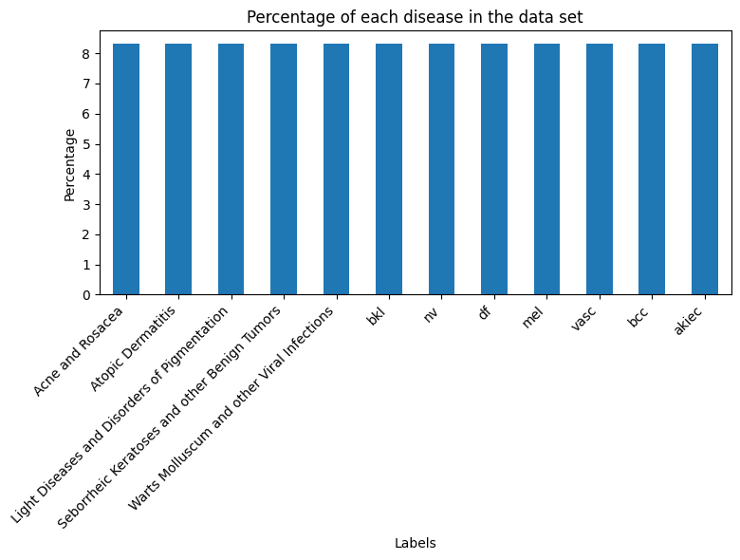

Figure 5-Distribution of diseases after augmentation.

**3.3. Machine Learning Model Implementation**

In our project, in terms of machine learning models, convolutional neural networks (CNNs) emerged as the predominant choice due to their exceptional performance in image classification tasks. Models such as DenseNet121[1], ResNet50[16], InceptionV3[17], and MobileNetV2[18] were frequently mentioned across the papers.

In our project, we selected these four well-known CNN architectures to classify skin diseases: DenseNet121, ResNet50, InceptionV3, and MobileNetV2. Each of these models was chosen for its unique strengths and proven effectiveness in image classification tasks, according to information gathered from reviewing multiple research papers on this topic.

We trained these models on the HAM dataset, using a batch size of 32 and 10 epochs. We utilized the Adam optimizer to ensure efficient training. After evaluating their performance, we found that MobileNetV2 was the best-performing model. Following this, we gradually increased the number of diseases from the Dermnet dataset, adding them sequentially to maintain a balance between the number of diseases and achieving the best possible accuracy. This approach allowed us to expand the range of diseases while maintaining a reasonable level of accuracy. This combination enables our system to provide reliable and efficient skin disease diagnosis, empowering users with timely and accurate medical insights.

**3.4. Integration of Machine Learning Model in Mobile Application**

### **3.4.1 Turning Machine Learning Model into API**

Integrating the artificial intelligence model with the Application Programming Interface (API) represents a vital step in enabling the application to seamlessly access its functionalities. Through this integration, the application gains the ability to communicate with the artificial intelligence model over the network, allowing it to send images for analysis and receive corresponding results. This interface acts as a bridge between the application's front-end user interface and the backend of the artificial intelligence model, facilitating smooth interaction and data exchange between the two components.

FastAPI stands out for its robust features, making it an excellent option for integration with Flutter applications. Utilizing (Asynchronous Server Gateway Interface) ASGI, FastAPI ensures rapid execution, facilitating quick responses to requests originating from Flutter applications. Its built-in support for asynchronous programming allows for concurrent handling of multiple requests, which proves beneficial, especially during scenarios involving simultaneous photo capture and prediction requests from various users. Furthermore, although not explicitly stated, FastAPI offers mechanisms like OAuth2.0 for implementing security measures. These capabilities contribute to securing API endpoints and protecting sensitive data exchanged between the Flutter application and the FastAPI server. In summary, FastAPI combination of high performance, concurrency support, and security features makes it a dependable and efficient choice for creating APIs seamlessly integrated with Flutter applications.

The API code is designed to take an image from the application, process it by performing essential steps like resizing and normalization to match the preprocessing done on the training data. This ensures consistency and accuracy in predictions. After preprocessing, the API calculates the confidence level and returns both the prediction and confidence score to the application.

### **3.4.2 Deploying the API on Server**

Deploying the API on the server is a critical step in transitioning the AI model to a production environment. This involves setting up a server that can efficiently handle incoming requests and return results to the client application. Through this deployment, the mobile application can communicate with the server in real-time, allowing users to send images for analysis and quickly receive diagnostic results. The process also includes configuring the server for scalability, security, and reliability to ensure it can manage multiple concurrent requests and safeguard sensitive user data. This deployment step is vital for providing a seamless user experience, bridging the gap between the AI model's capabilities and the needs of end-users, and making advanced skin disease diagnosis readily accessible.

In our efforts to deploy the API, we explored several hosting services such as Google Cloud Platform, Heroku, Python anywhere and Amazon Web Services. However, we encountered limitations such as cost. Additionally, after deployment, we faced restrictions on modifying the published program, hindering our ability to adapt and improve the system as needed.

Finally, we opted to use a render server, which proved advantageous in several ways. Firstly, it offered greater flexibility and control over the deployment environment compared to other hosting services. This allowed us to tailor the server setup to our specific requirements and make necessary adjustments as needed. Additionally, using a rendering server helped mitigate the limitations we faced with other hosting options, such as restricted CPU and RAM capacity, by providing us with 512 MB of RAM and 0.1 CPU capacity.

## **3.5. Mobile Application**

The mobile application is built using Flutter and serves as the central hub for users to interact with the system. It provides a seamless and intuitive interface for users to capture images of their skin conditions and receive AI-driven diagnoses. Flutter was chosen for its ability to deliver a consistent user experience across multiple platforms, including iOS and Android, ensuring broad accessibility for users. The application focuses on guiding users through the image capture process and presenting diagnoses clearly and understandably, while encouraging professional medical consultation and providing clinic locations. It also offers options such as comparing AI diagnoses with those of a doctor, voluntary data contribution to improve the models.

### **3.5.1 User Interface**

The user interface (UI) of the mobile application is designed with user-friendliness and accessibility in mind. Key features of the UI include:

**Simple Navigation**: Intuitive menus and clear instructions to guide users through the app.

**Image Capture and Upload**: Easy-to-use camera functionality for capturing new images and options to upload existing photos.

**Diagnosis Display**: Clear and detailed presentation of AI-driven diagnoses, additional medical report.

**Professional Consultation**: Links to nearby clinics and options to consult with dermatologists for further diagnosis.

**Data Management**: Secure access to personal medical history, submitted images, and received diagnoses.

### **3.5.2 Login Process**

The login process in our mobile application is designed to ensure both security and ease of use, tailored for both patients and dermatologists.

1. **Patient Login**
2. **Personal Information Entry**: Patients are required to enter their personal information, including age, gender, and other relevant details.
3. **Data Storage**: This information is securely stored in the Firebase database. Passwords are encrypted by the SCRYPT hashing algorithm to ensure data protection and privacy.
4. **Email Verification**: After signing up, an email is sent to the patient for verification. The patient must follow the instructions in the email to verify their access.
5. **Unique User Type**: If a user logs in as a patient, they cannot use the same email to log in as a dermatologist, ensuring clear separation of roles and preventing conflicts in access.
6. **Dermatologist Login**
7. **Professional Information Entry**: Dermatologists need to enter detailed information about themselves, including their professional experience and clinic information.
8. **Data Storage**: Like patients, this information is securely stored in the Firebase database with encrypted passwords by the SCRYPT hashing algorithm to maintain high levels of security and privacy.
9. **Email Verification**: Dermatologists also receive a verification email upon signing up, which they must use to confirm their account.
10. **Unique User Type**: If a user logs in as a dermatologist, they cannot use the same email to log in as a patient, maintaining a clear distinction between the two user types.

This structured login process ensures that all users provide necessary and accurate information, while also maintaining the security and integrity of their data. By verifying emails and encrypting passwords, we protect user information and provide a secure platform for both patients and dermatologists.

### **3.5.3 Patient Process**

The application allows patients to either upload an existing photo or take a new one. Once the image is captured or selected, it is sent via an HTTP request to the Render server that contains the model's API for analysis. The server processes the image using an integrated AI model to provide a diagnosis and accurate assessment. This seamless process allows users to obtain initial diagnoses of their skin conditions quickly and effortlessly, thus enhancing access to healthcare resources.

After that, the application offers users several options:

* **Clinic Locator**: Providing nearby clinics by filtering the information the user provides about their location.
* **Diagnosis Verification**: Offering the option to verify the validity of the application's diagnosis with a professional dermatologist and provide him with any additional symptoms for a more accurate diagnosis.
* **Health Report**: The user can obtain a reliable health report on the disease predicted by the application, explaining how the disease manifests and any other symptoms associated with it.

The application emphasizes to the user the importance of consulting a doctor, stating that this preliminary diagnosis does not substitute for a visit to the doctor.

Additionally, patients can easily review and modify the information they provided about themselves, access their medical history, view all the images they have submitted, and see the diagnoses they have received from either the doctor or the application. They can also easily access any instructions provided by the doctor.

### **3.5.4 Dermatologist Process**

The mobile application offers numerous benefits for dermatologists:

* **Clinic Visibility**: Allows them to display the location of their clinic, enhancing their visibility and potentially increasing their practice's reach.
* **Diagnosis Verification**: Dermatologists can verify the application's diagnosis and provide a more accurate diagnosis, ensuring high-quality care for patients.
* **Data Contribution**: By contributing to the verification of patient-donated data, dermatologists can actively participate in the continuous development and improvement of the application's database and functionality, thereby enhancing the overall effectiveness of the program.
* **Professional Management**: Doctors can update their information, add new experiences, access their history, and review all diagnoses they have made through the application, as well as the diagnoses they have verified for volunteering. This ensures that dermatologists can keep track of their professional activities and contributions to the application's development.

### **3.5.5 Volunteering Data in the Mobile Application**

In the mobile app's volunteer data feature, patients who have received a diagnosis for their skin condition can choose to contribute their photos for further analysis and improvement of the model. Once a patient receives a diagnosis from a doctor after requesting their image to be diagnosed, they are given the option to volunteer their image for additional analysis by medical professionals.

When selecting the volunteering option, the patient's photo undergoes further evaluation by three additional doctors who were not involved in the initial diagnosis. These doctors independently review the photo and provide their own diagnoses. The purpose of involving multiple doctors is to ensure a diverse range of medical opinions and verify the accuracy of the initial diagnosis.

If the three doctors reach a consensus and agree on the same diagnosis the image is considered suitable for inclusion in the database. The image is stored in the database for use in training the artificial intelligence model. By including diverse and authenticated images in the training dataset, the model becomes more robust and capable of diagnosing a wider range of skin conditions.

### **3.5.6 Firebase Database Structure**

1. **Collections Overview:**
   * The Firebase database comprises five primary collections: patients, dermatologists, patient history, dermatologist history, and volunteer data.
2. **Patients Collection:**
   * Documents representing individual patients, identified by their email addresses.
   * Stores essential patient data such as personal information, medical history, and contact details.
3. **Dermatologists Collection:**
   * Documents representing individual dermatologists, identified by their email addresses.
   * Stores essential dermatologist data such as professional credentials, specialization, and contact details.
4. **Patient History Collection:**
   * Contains documents representing patients’ medical histories, identified by their email addresses.
   * Includes a subcollection named predictions for detailed prediction records related to the patient's condition.
5. **Dermatologist History Collection:**
   * Contains documents representing dermatologists' diagnosis histories, identified by their email addresses.
   * Includes a subcollection named diagnosis for detailed diagnosis records made by the dermatologist.
6. **Volunteer Data Collection:**
   * Contains documents representing volunteer data derived from patients and their diagnoses by dermatologists.
   * Includes a flag to indicate the agreement of three dermatologists on the same diagnosis, ensuring data reliability.
   * Stores combined information from patients and dermatologists relevant to volunteer studies and research.

**2.Functional Insights**

* **User Identification:**
  + Email addresses serve as the main identifiers for both patients and dermatologists, ensuring uniqueness and easy access.
* **Data Segregation:**
  + Medical history and predictions are segregated into patient history and its predictions subcollection.
  + Diagnosis history is segregated into dermatologist history and its diagnosis subcollection.
* **Prediction and Diagnosis Management:**
  + Subcollections under patient history and dermatologist history allow for detailed tracking and management of predictions and diagnoses, respectively.
* **Volunteer Data Utilization:**
  + The volunteer data collection integrates data from patients and dermatologists, ensuring reliable volunteer-based research through verification mechanisms.

The encryption used in Firebase Authentication relies on the SCRYPT hashing algorithm, which ensures secure storage of passwords. This algorithm utilizes several parameters for password hashing, each contributing to the overall security of the system.

Using Firebase Storage to store patient images securely and efficiently can be seamlessly integrated with Firebase Firestore for documentation. When an image is uploaded to Firebase Storage, it generates a URL that can be stored in Firestore. This process ensures that the image is securely stored while allowing for fast access when needed.

Here’s a brief overview of the process:

**1**. Upload Image to Firebase Storage: Use Firebase Storage to upload the patient image.

**2**. Get Image URL: Once the image is uploaded, Firebase Storage provides a download URL for the image.

**3**. Store URL in Firestore: Save the image URL in Firestore under the relevant patient document. This ensures that the image is linked to the patient's records securely.

**4**. Fetch Image Quickly: When retrieving patient information, fetch the image URL from Firestore and use it to display the image directly from Firebase Storage.

This integration of Firebase Storage and Firestore ensures that patient images are stored securely and can be accessed quickly, maintaining both security and efficiency in handling medical records.

This structured database supports a comprehensive system for managing patient and dermatologist data, tracking medical and diagnostic histories, and facilitating volunteer-based research effectively. The use of subcollections enables detailed and hierarchical data storage, while the email-based document ID strategy ensures simplicity and integrity in user identification throughout the system.

Fig-6 represents the collections on firebase and documentation of each collection, and Fig-7 represents the flowchart of the mobile application.

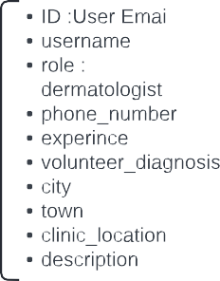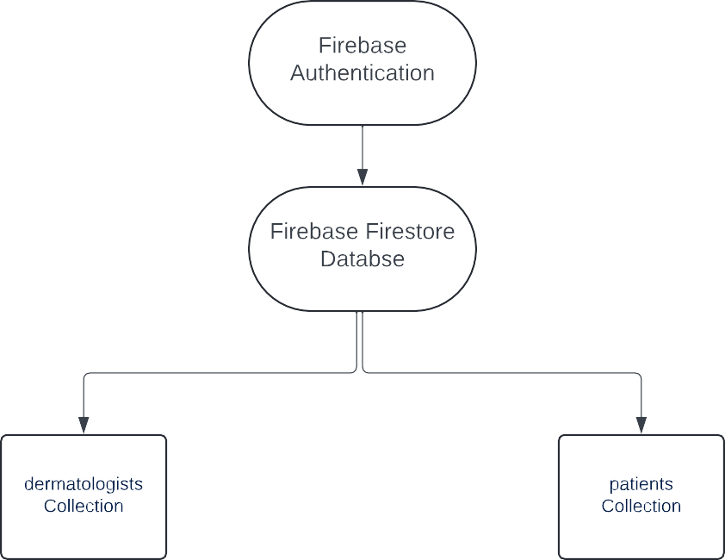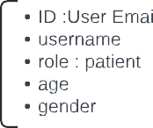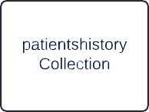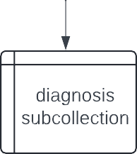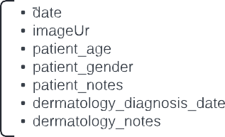

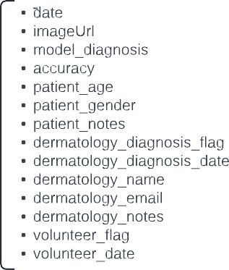

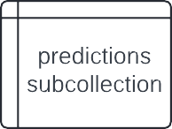

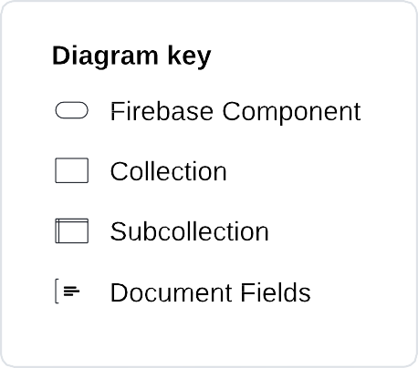

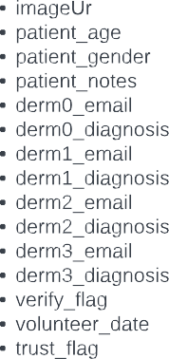

Figure 6 - Firebase Structure

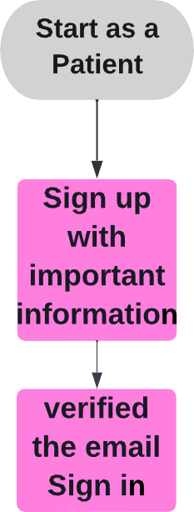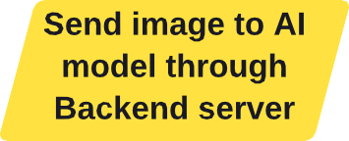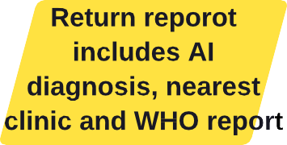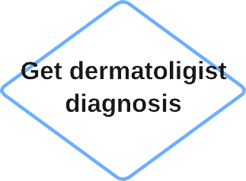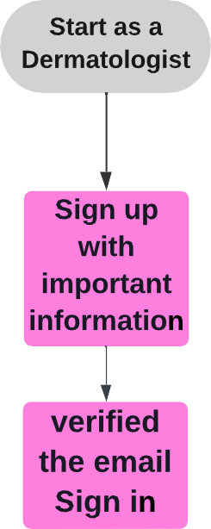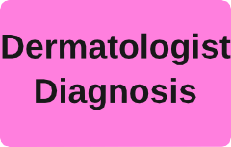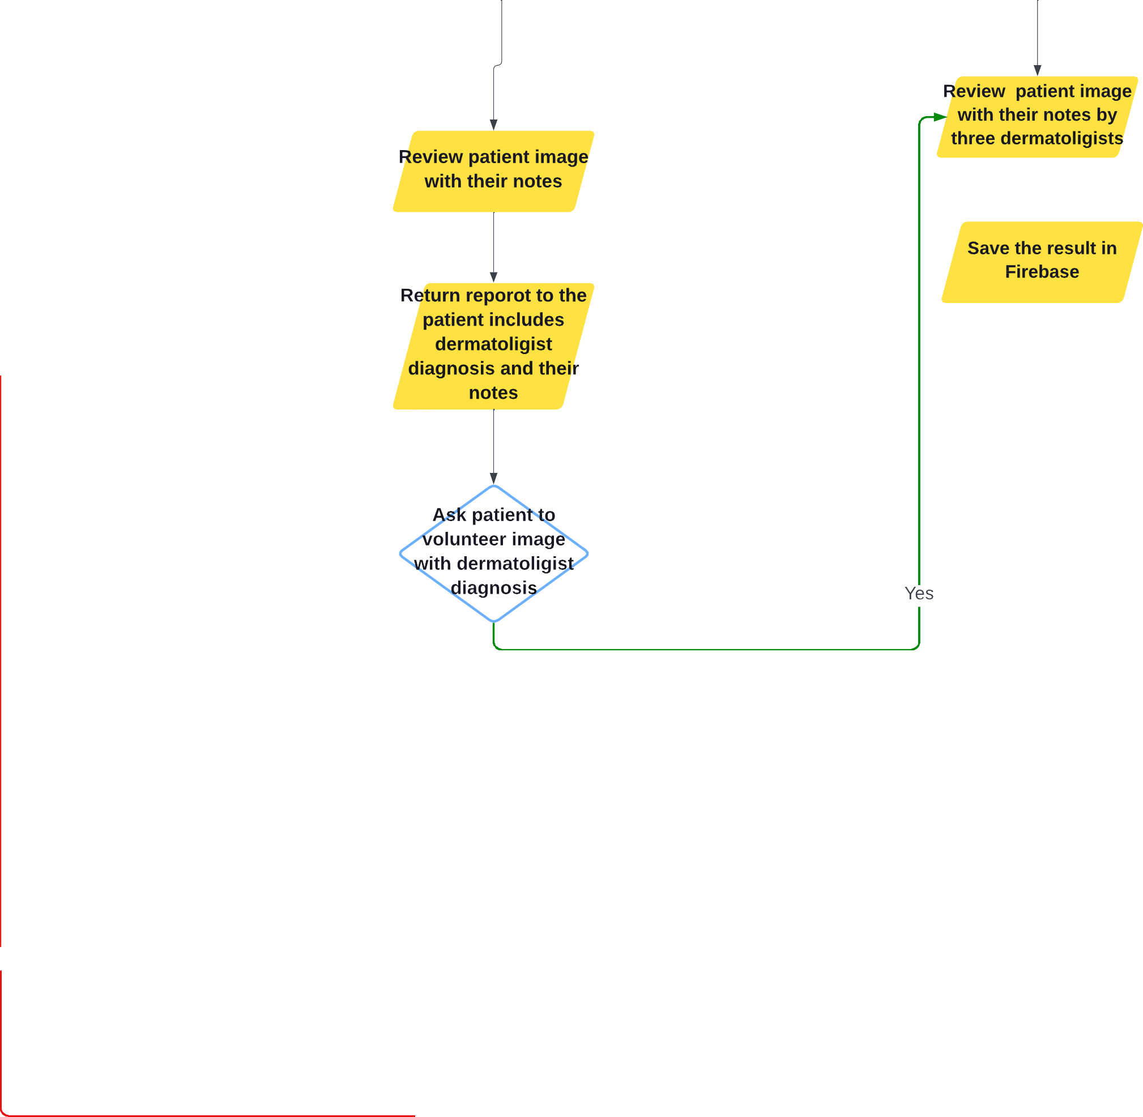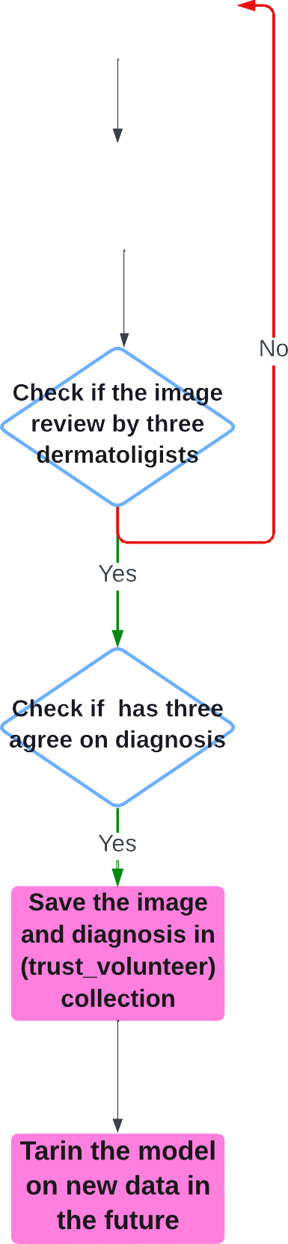

Figure 7 - Mobile Application Flowchart

# **CHAPTER 4 RESULTS AND DISCUSSION**

## **4.1. Machine Learning Model Result**

After conducting experiments on the HAM dataset using various machine learning models, we obtained the following results:

* The DenseNet121 model achieved an accuracy of 82%, indicating its effectiveness in classifying skin diseases.
* Following closely, the ResNet50 model attained an accuracy of 81%, showcasing its strong performance in the task.
* Meanwhile, the InceptionV3 model achieved 70% accuracy, indicating moderate success in classification.
* However, the MobileNetV2 model emerged as the best performer among the models, with an impressive accuracy of 89%, highlighting its suitability and outstanding performance in classifying skin diseases.

Based on these findings, we proceeded by selecting diseases from the Dermnet dataset and trained them using the same model. We gradually increased the number of diseases, finding the optimal ratio for performance.

The dataset and AI model outcome involved integrating twelve diseases from both the HAM and Dermnet datasets. Each disease category underwent meticulous augmentation to include a total of 2000 images, ensuring a comprehensive and diverse training dataset.

To maintain a balanced ratio between the number of diseases and accuracy, it was decided to include a total of twelve diseases, comprising 5 from the Dermnet dataset and 7 from the HAM dataset, resulting in an overall accuracy rate of 74.8%. This strategic selection aimed to optimize the model's performance while ensuring representation from a diverse range of skin conditions, thus enhancing its practical utility in clinical settings.

Table 1 offers a detailed comparison of model accuracy across different datasets. It highlights the accuracy percentages achieved by four models - DenseNet121, ResNet50, InceptionV3, and MobileNetV2 - when evaluated on the HAM dataset. MobileNetV2 notably outperformed the other models with the highest accuracy of 89%. Notably, as more diseases were included from the Dermnet dataset, the accuracy gradually decreased, as illustrated in the table.

Fig 8- Illustrates the accuracy of testing the model on the test dataset. Accuracy is measured when testing the model using the test dataset to evaluate the model's effectiveness in predicting the correct classes.

Table 2 Comparison of Model Accuracy on Datasets

|  |  |  |
| --- | --- | --- |
| **Model** | **Dataset** | **Accuracy (%)** |
| DenseNet121 | HAM | 82 |
| ResNet50 | HAM | 81 |
| InceptionV3 | HAM | 70 |
| MobileNetV2 | HAM | 89 |
| MobileNetV2 | Ham with adding single different disease from Dermnet dataset | 60-80 |
| MobileNetV2 | HAM with one disease from Dermnet dataset | 80 |
| MobileNetV2 | HAM with two diseases from Dermnet dataset | 78 |
| MobileNetV2 | HAM with three diseases from Dermnet dataset | 76 |
| MobileNetV2 | HAM with four diseases from Dermnet dataset | 75 |
| MobileNetV2 | HAM with five diseases from Dermnet dataset | 74.8 |
| MobileNetV2 | HAM with six diseases from Dermnet dataset | 72 |

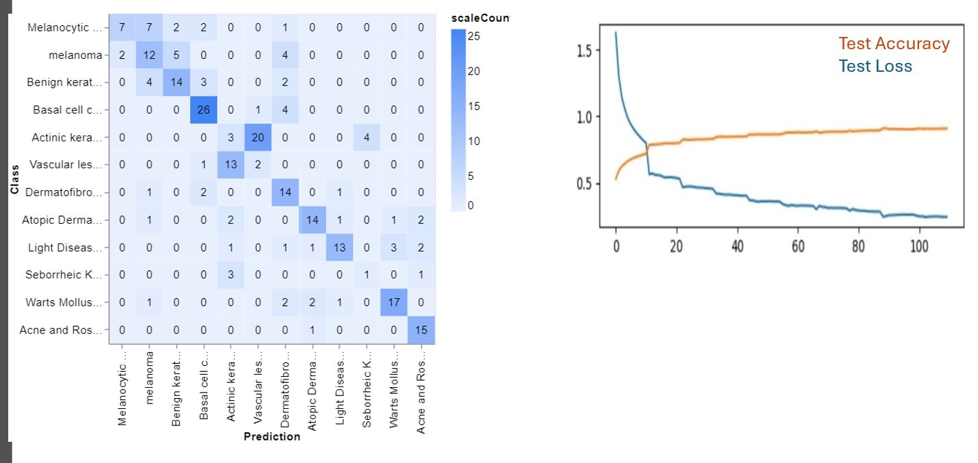

Figure 8 - Accuracy for testing the model on the test dataset.

## **4.2. Mobile Application Result**

### **4.2.1 User Authentication and Security**

* Patient Login: Users are prompted to input personal details, including age and gender, securely stored in Firebase.
* Dermatologist Login: Detailed professional information is required, enhancing authentication and data integrity.
* Email Verification: Both patients and dermatologists undergo email verification post-registration for account authentication.
* Unique User Type: A clear separation between patient and dermatologist roles is maintained to avoid access conflicts.

Figure 9-Sign up process.

### **4.2.2 Patient Diagnosis Process**

* Image Capture and Analysis: Patients can upload or capture images for diagnosis, processed via an AI model on the Render server.

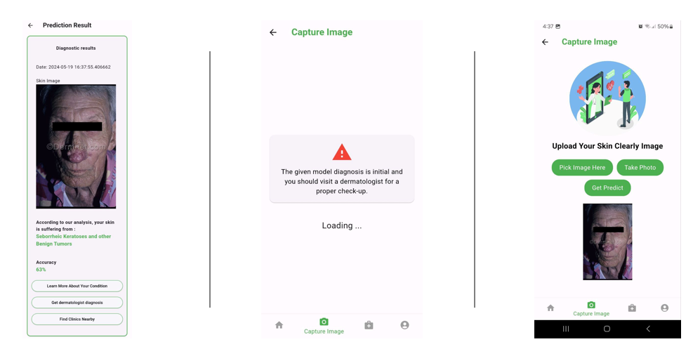

Figure 10-Capture Image process.

* Diagnosis Verification: Options to validate diagnoses with local dermatologists ensure accuracy.
* Health Reports: Users receive comprehensive health reports, emphasizing the importance of consulting a doctor.
* Clinic Locator: Providing nearby clinics by filtering the information the user provides about their location. Fig10 represents the application has several options offered to users.

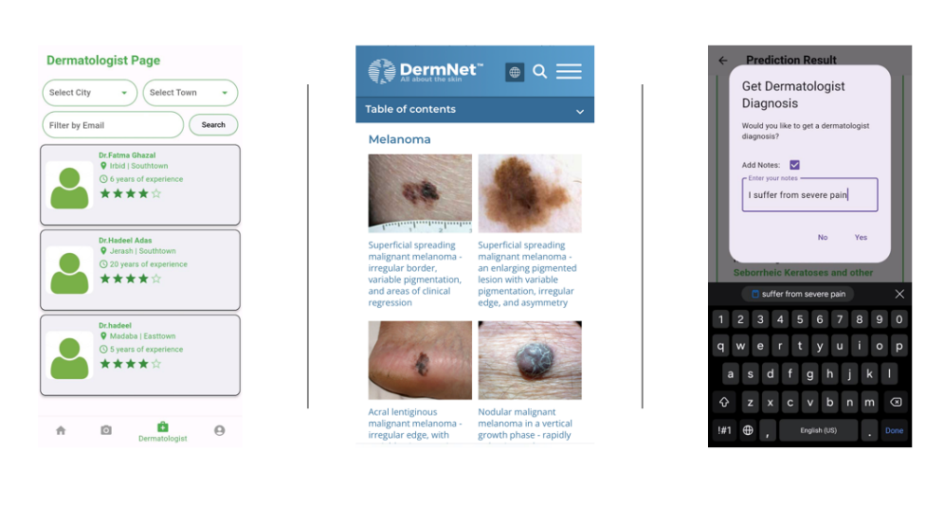

Figure 11-Patient Options

* Data Accessibility: Patients can review, modify, and access their medical history and diagnoses conveniently within the application as shown in Fig11.

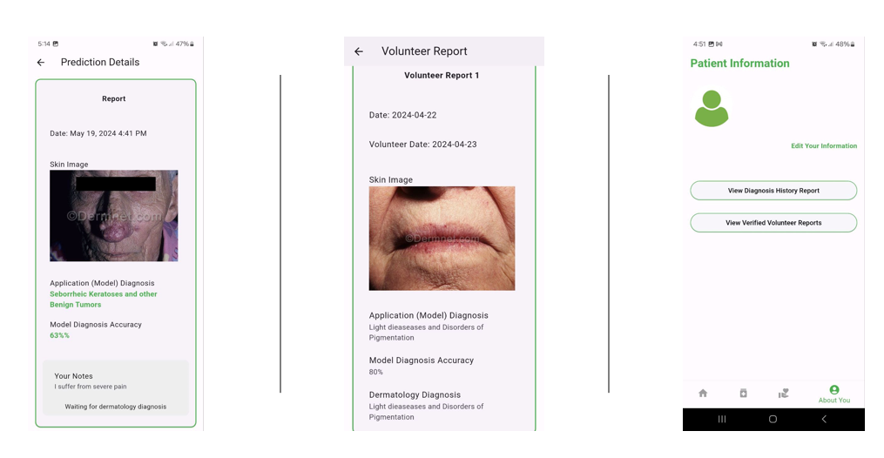

Figure 12-Data Accessibility by patient.

### **4.2.3 Dermatologist Interface**

* Clinic Visibility: Dermatologists can enhance visibility by displaying clinic locations within the app.
* Diagnosis Verification: Enables dermatologists to verify and provide accurate diagnoses, ensuring quality care.
* Data Contribution: Dermatologists' involvement in verifying patient data improves database accuracy and functionality.

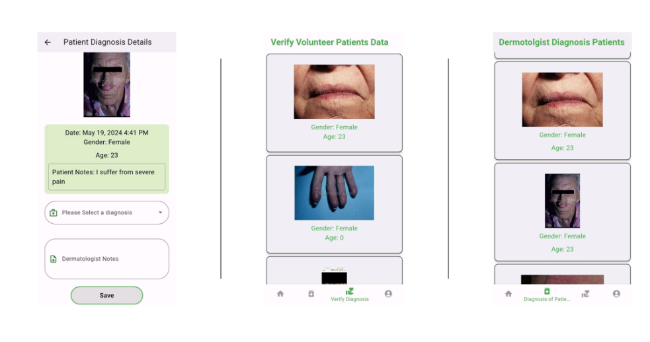

Figure 13-Dermatologist Diagnosis process

* Professional Management: Allows dermatologists to manage their profiles, track activities, and contribute to app development as shown in Fig-13.

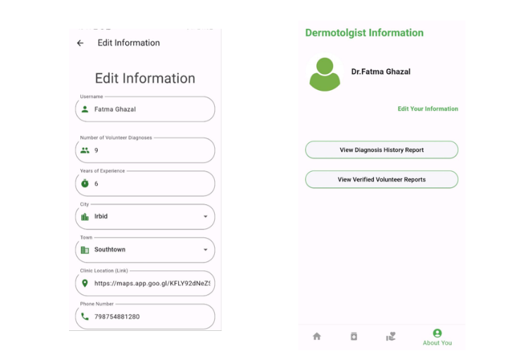

Figure14-Data Accessibility by Dermatologist

### **4.2.4 Volunteer Data Contribution**

* Patient Participation: Patients can volunteer their images for further analysis, contributing to model improvement.
* Multi-Doctor Evaluation: Images undergo evaluation by three additional doctors, ensuring diverse medical opinions and diagnosis accuracy.
* Database Inclusion: Images with consensus diagnoses are stored, enriching the training dataset for enhanced AI model capabilities.

# **CHAPTER 5 CONCLUSIONS AND FUTURE WORK**

## **Conclusions**

Our project marks a significant advancement in dermatological care, representing a transformative milestone in the healthcare landscape. By harnessing cutting-edge technologies such as artificial intelligence and mobile applications, we have redefined the way skin diseases are diagnosed and managed. Through our innovative platform, patients now have unprecedented access to accurate and timely medical insights, empowering them to take proactive steps towards better skin health. This paradigm shifts towards a more digitally enabled healthcare approach not only enhances the efficiency and effectiveness of dermatological care but also underscores the importance of embracing technology to address evolving healthcare challenges.

## **Future Work**

In future iterations of our project, one key aspect to consider is the expansion to iOS devices by leveraging Flutter's cross-platform capabilities. By developing an iOS version of the application, we can reach a broader audience of users who prefer Apple devices, thereby enhancing accessibility and inclusivity. Additionally, we plan to capitalize on the volunteered data collected within the application to further train and refine our AI model. This iterative training process will improve the accuracy and effectiveness of the diagnostic capabilities, ultimately providing more reliable insights to users. Another avenue for future work involves increasing the number of participating dermatologists and clinics within the application. By expanding our network of healthcare providers, we can offer users a wider range of options for seeking specialized care and expertise. Furthermore, we aspire to broaden the geographical coverage of the application by including clinics and healthcare facilities from multiple countries. This global expansion not only facilitates access to dermatological services for users worldwide but also fosters collaboration and knowledge-sharing among medical professionals across borders. Also, we plan to upgrade our server infrastructure to optimize model deployment and data management. By utilizing a more robust server, we can ensure faster model deployment and efficient handling of user data.

Overall, these future endeavors aim to enhance the reach, effectiveness, and inclusivity of our dermatological care platform, advancing our mission to revolutionize skin health management on a global scale.

**REFERENCES**

* 1. [1] DermEngine, <https://www.dermengine.com/> [Accessed: October 15, 2023].

[2] VisualDx, <https://www.visualdx.com/> [Accessed: October 15, 2023].

[3] Model Dermatol – Skin Disease,<https://www.appbrain.com/app/model-dermatol-skin-disease/com.phonegap.whichderm> [Accessed: October 15, 2023].

[4] FirstDerm, <https://firstderm.com/>,[Accessed: October 15, 2023].

[5] very well health,<https://www.verywellhealth.com/best-online-dermatologists-5095650> [Accessed: October 15, 2023].

[6] 5-fold High-order Attention Interaction Model for Skin Segmentation Derived Classification, <https://arxiv.org/abs/2311.15625> ,[Accessed: October 22, 2023].

[7] Multi-task Explainable Skin Lesion Classification, <https://arxiv.org/abs/2310.07209>

[8] AI-based localization and classification of skin disease with erythema, <https://www.nature.com/articles/s41598-021-84593-z> ,[Accessed: October 22, 2023].

[9] Skin Disease Detection: Machine Learning vs Deep Learning, <https://www.researchgate.net/publication/354580578_Skin_Disease_Detection_Machine_Learning_vs_Deep_Learning> ,[Accessed: October 23, 2023].

[10] Skin Disease Classification System Based on Machine Learning technique, <https://www.researchgate.net/publication/349618038_Skin_Disease_Classification_System_Based_on_Machine_Learning_Technique_A_Survey> ,[Accessed: October 23, 2023].

[11] Skin lesion analysis-toward melanoma, <https://paperswithcode.com/paper/skin-lesion-analysis-toward-melanoma> ,[Accessed: October 24, 2023].

[12] Detection and diagnosis of skin diseases by using snake algorithm and neural networks, <https://www.techniumscience.com/index.php/technium/article/view/7840> ,[Accessed: October 24, 2023].

[13] Towards improving diagnosis of skin diseases by combining deep neural network and human knowledge, <https://bmcmedinformdecismak.biomedcentral.com/articles/10.1186/s12911-018-0631-9>,

[Accessed: October 25, 2023].

[14] Human Skin Diseases Detection and Classification using CNN, <https://www.researchgate.net/publication/370132443_Human_Skin_Diseases_Detection_and_Classification_using_CNN> , [Accessed: October 25, 2023].

[15]Implementing DenseNet-121 in PyTorch: A Step-by-Step Guide, <https://medium.com/deepkapha-notes/implementing-densenet-121-in-pytorch-a-step-by-step-guide-c0c2625c2a60> ,[Accessed: December 25, 2023].

[16] resnet-50, <https://datagen.tech/guides/computer-vision/resnet-50/> ,[Accessed: December 30, 2024].

[17] InceptionV3, <https://paperswithcode.com/method/inception-v3> ,[Accessed: December 15, 2024].

[15] MobileNetV2,<https://keras.io/api/applications/mobilenet/> [Accessed: January 10, 2023].

**APPENDICES**

**Gannt Chart of Our Work:**

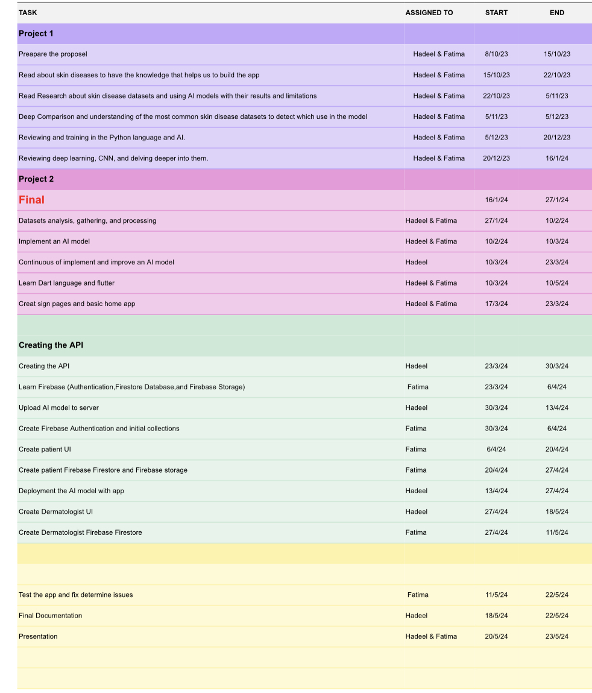

Figure 15-Gantt Chart.